# COMP3500: Deadlock Detection

**Exercise 1 (Plickers):** Let’s consider a system where there is a single instance per resource type. Which one of the following statement on deadlock detection is incorrect?

1. Maintain a wait-forgraph
   1. Nodes are processes
   2. ***Pi* → *Pj*** if ***Pi***is waiting for***Pj***
2. Periodically invoke an algorithm that searches for a cycle in the graph.
3. If there is a cycle, there exists a deadlock
4. An algorithm to detect a cycle in a graph requires an order of***n*logn*** operations, where ***n*** is the number of vertices in the graph

**Exercise 2 (Plickers).** What is the time complexity of the detection algorithm?

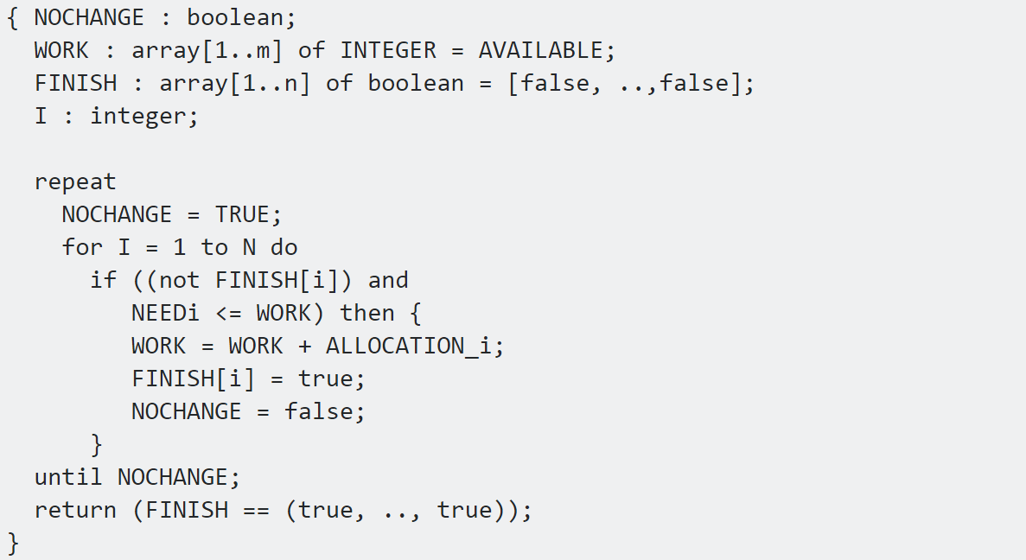

1. O(n2) B. O(m x n2) C. O(m2) D. O(m x n)